ARYAMAN MISHRA

19BCE1027

1)

<!doctype html><head><title>Registration Form</title>

<style>

h1

{

color:orange;

}

td

{

color: wheat;

}

p{

color: lightblue;

}

background {

opacity: 0.5;

}

</style>

</head>

<body background="c6e0934db74bcd931f946f86791f116c.jpeg">

<table align="center" width="70%" border="1">

<tr><td height="43" colspan="2" align="center"><h1> SummerSlam 2020</h1></td></tr><tr>

<tr><td height="43" colspan="2" align="center"><h2>Registration Form for the Visually Impaired</h2></td></tr>

<tr>

<td width="46%"><audio controls>

<source src="../Downloads/Name.mp3" type="audio/mp3">

</audio>

Enter your Name:</td>

<td width="54%"><input type="text" name="name" id="name" placeholder="Enter your name" required></td>

</tr>

<tr>

<td width="46%"><audio controls>

<source src="../Downloads/Gender.mp3" type="audio/mp3">

</audio>Gender:</td>

<td width="54%">

<select name="mygender" id="mygender" required>

<option value="0">-----Select Your Gender-----</option>

<option value="M">Male</option>

<option value="F">Female</option></select></td></tr>

<td height="60"><audio controls>

<source src="../Downloads/Address.mp3" type="audio/mp3">

</audio>Your Complete Address:</td>

<td><textarea name="completeaddress" id="completeaddress"></textarea></td>

<tr>

<td><audio controls>

<source src="../Downloads/Date of Birth.mp3" type="audio/mp3">

</audio>Date of Birth:</td>

<td><input type="date" id="start" name="trip-start"

value="2002-10-13"

min="1900-01-01" max="2020-12-31"></td>

</tr>

<td><audio controls>

<source src="../Downloads/E-Mail.mp3" type="audio/mp3">

</audio>Your E-Mail:</td>

<td><input type="text" name="myemail" id="myemail" required placeholder="Enter your Mail"></td>

</tr>

<td><audio controls>

<source src="../Downloads/Contact.mp3" type="audio/mp3">

</audio>Contact:</td>

<td><input type="number" name="mycontact" id="mycontact" placeholder="Enter your Contact"></td>

</tr>

<tr>

<td><audio controls>

<source src="../Downloads/Password.mp3" type="audio/mp3"></audio>Password:</td>

<td>

<input type="password" id="pwd" placeholder="Enter your Password"></td></tr>

<td><audio controls>

<source src="../Downloads/Re-enter.mp3" type="audio/mp3">

</audio>Re-enter Your Password:</td>

<td><input type="password" id="pwd" placeholder="Re-Enter your Password"></td>

</tr>

<tr>

<td width="46%"><audio controls>

<source src="../Downloads/Seat.mp3" type="audio/mp3">

</audio>Seat Preference:</td>

<td width="54%">

<select name="quota" id="quota" required>

<option value="N">-----Enter Seat-----</option>

<option value="B">Balconey</option>

<option value="M">Medium</option>

<option value="BA">Base</option>

<option value="RA">Ringside Area</option>

</select></td></tr>

<tr><td align="center" colspan=2><input type="submit" name="submit" id="submit" value="Submit this form" bgcolor="yellow"/><input type="button" bgcolor="orange" value="Reset"/></td></tr>

</table>

</body>

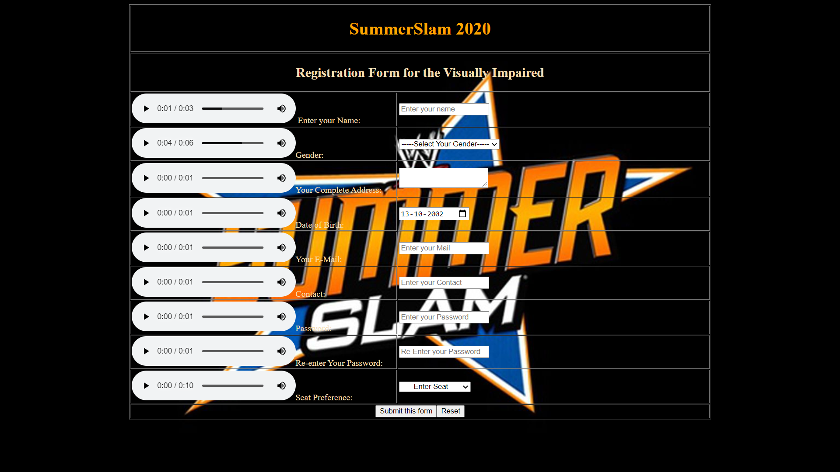

2) <!doctype html>

<html>

<head>

<meta charset="UTF-8">

<title>Our new webpage</title>

<link rel="stylesheet" type="text/css" href="styles.css">

</head>

<body>

<div class="container">

<header>

<ul class="nav_menu" >

<li><a href="index.html">Home</a></li>

<li><a href="about.html">My Blog</a></li>

<li><a href="contact.html">Contact Me</a></li>

<li></li>

</ul>

<div id="logo"></div>

<div class="clear"><a href="#"><img src="../maxresdefault.jpg" width="961" height="159"></a></div>

</header>

<section id="mainBody">

<div id="welcomeDiv">

<p><a><img src="../Fall Semester 2020-21/7fbb1e84e15b21548865263f90767a70.png" width="166" height="111"></a></p>

<h2> Welcome to my page</h2>

<p>Hey guys this is the man himself.I am Aryaman Mishra and I'm currently pursuing my B.Tech Degree at Vellore Institute of Technology,Chennai.I was born and raised in Lucknow,Uttar Pradesh.I studied at City Montessori School,one of the most distinguished colleges in my city.I am a combat sports fanatic and a drummer.I am currently learning to play the bass guitar and the keyboard(talk about being multi-talented).I love Hollywood films and playing Games.</p>

<p>I'm a bit of a computer wiz they say;i've been a software professional for around 10 years now and have worked in a number of computer programming languages and operating system.</p>

<p>&nbsp;</p>

</div>

<div id="newsLetter">

<p><h2>Achievements:</h2></p>

<p>1)Class Valedictorian in ISC 2019.</p>

<p>2)Best Skit.</p>

<p>3)Best Speech at TOI Speaking Competition..</p>

<p>4)Best Speaker For the Motion in inter-house debate.</p>

<p>5)Best drummer and pianist.</p>

<p>6)Best directed Skit.</p>

</div>

<p>&nbsp;</p>

<div class="clear"></div>

<div id="leftDiv">

<p><h2>Events Participated:</h2></p>

<p>1)Artificial Intelligence Concave.

</p>

<p>2)Develop your own Website Workshop.</p>

<p>3)Smartbot/Chatbot Workshop.</p>

<p>4)JAVA Workshop.</p>

<p>5)Hackathon.</p>

<p>6)Introduction to AI and Machine Learning;Developing your own Tensorflow Recognition Programme.</p>

</div>

<div id="rightDiv">

<p><h2>Awards:</h2></p>

<p>1.National Astronomical Olympiad Winner.</p>

<p>2.Lucknow Wrestling Alliance Cruiserweight Champion.</p>

<p>3.Best Drum Solo at Muzikotsava(2017).</p>

<p>4.Best Short Film at CMS.</p>

<p>5.Call of Duty Tournament Winner.</p>

<p>6.Best Game Creator.</p>

<p>7.1st Place in JAVA Coding Competition.</p>

</div>

</section>

<div class="clear"></div>

<footer>Copyright Mine</footer>

</div>

</body>

</html>

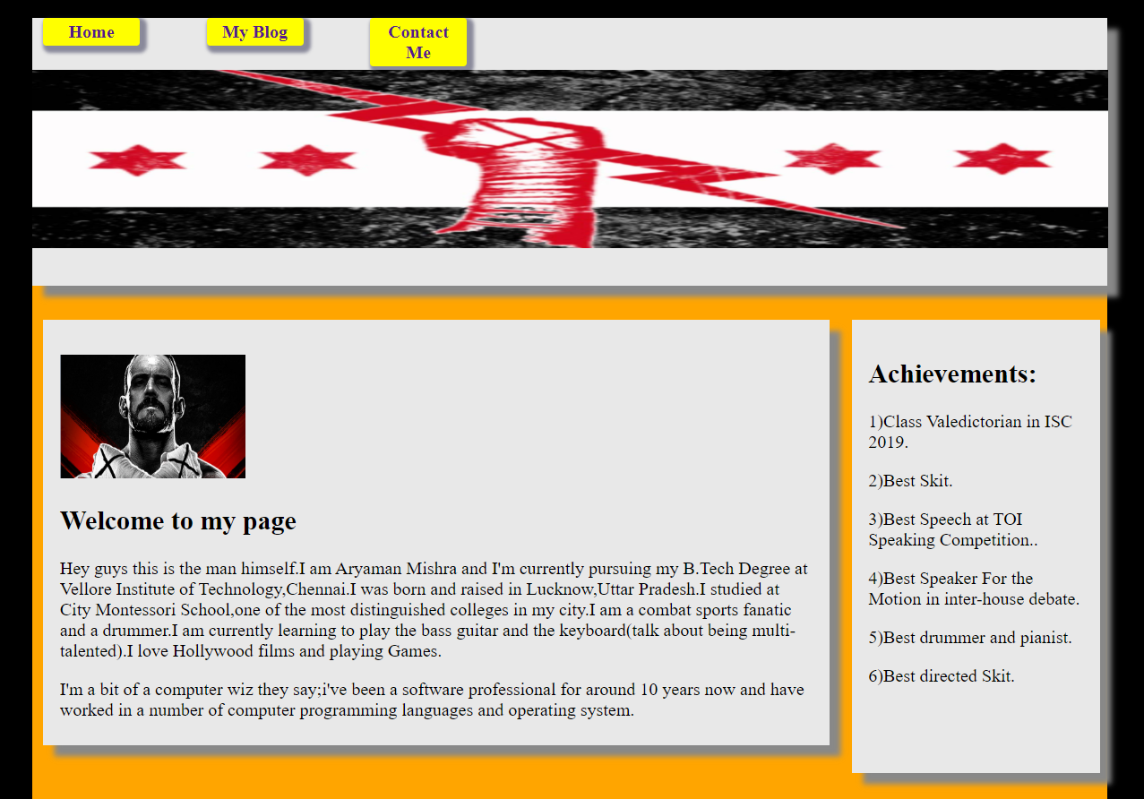

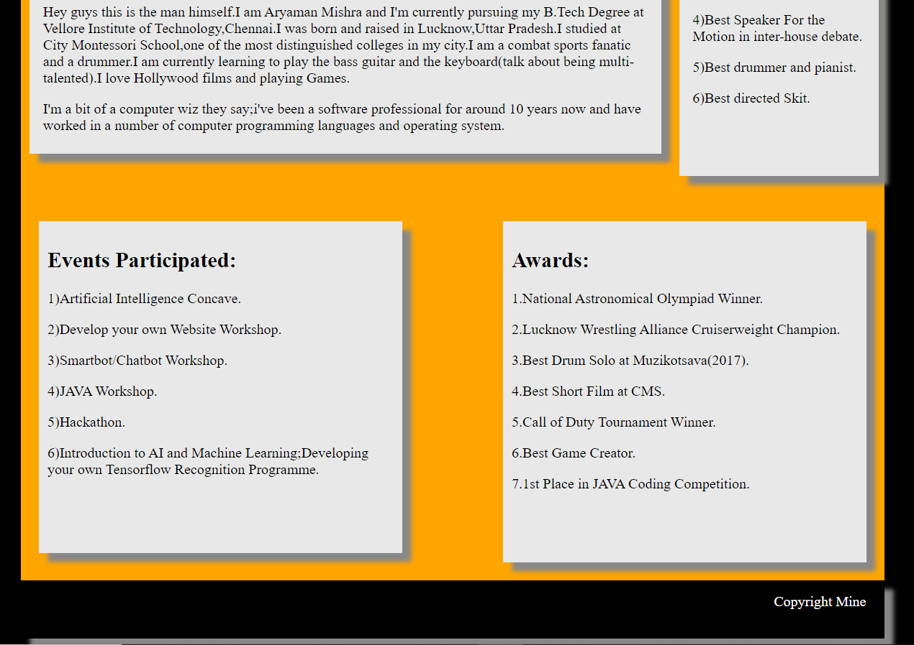

3)

<!doctype html>

<html>

<head>

<meta charset="utf-8">

<title>Untitled Document</title>

</head>

<body>

<canvas id="myCanvas" width="450" height="450" style="border:1px solid #d3d3d3;">

Your browser does not support the HTML5 canvas tag.</canvas>

<script>

var canvas = document.getElementById("myCanvas");

context = canvas.getContext("2d");

context.beginPath();

context.fillStyle="lightblue"; // #ffe4c4

context.arc(200, 50, 50, 0, Math.PI * 2, true);

context.stroke();

//draw circle for head

// (x,y) center, radius, start angle, end angle, anticlockwise

context.fill();

context.beginPath();

// body

context.beginPath();

context.moveTo(200, 100);

context.lineTo(200, 180);

context.strokeStyle = "black";

context.stroke();

// arms

context.beginPath();

context.strokeStyle = "black";

context.moveTo(200, 100);

context.lineTo(150, 130);

context.moveTo(200, 100);

context.lineTo(250, 130);

context.stroke();

// legs

context.beginPath();

context.strokeStyle = "black";

context.moveTo(200, 180);

context.lineTo(150, 280);

context.moveTo(200, 180);

context.lineTo(250, 280);

context.stroke();

</script>

</body>

</html>

